SharkFest ’18 US
Wireshark Developer and User Conference
June 25th - 28th, 2017 Computer History Museum, Mountain View, CA

SharkFest’18 US Sponsorship Form

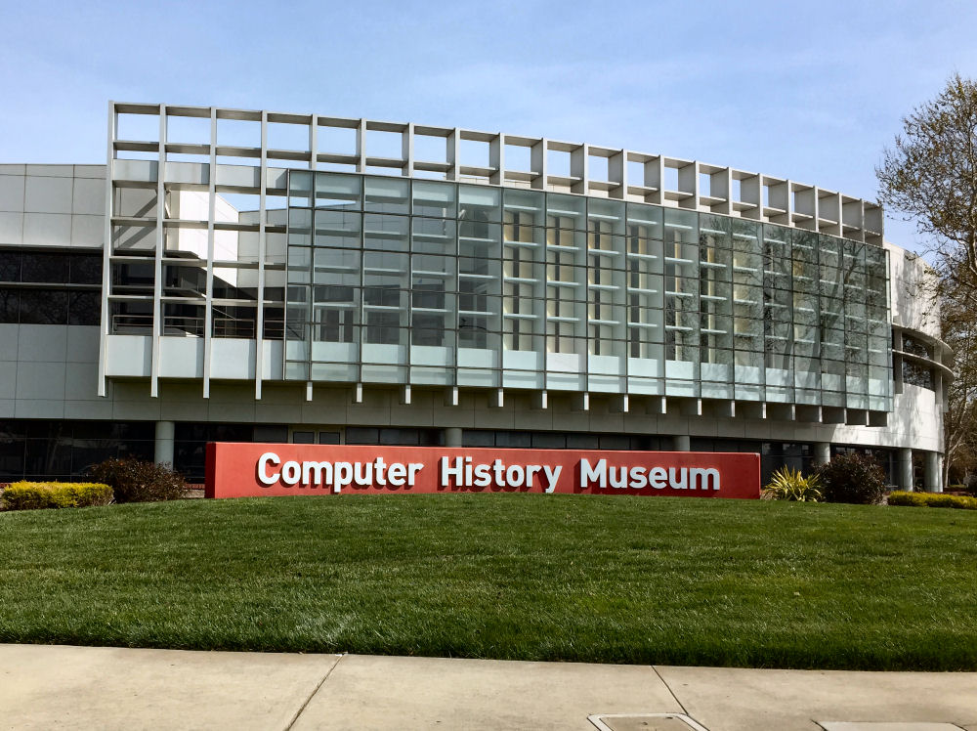

SharkFest US returns to the west coast and to the Computer History Museum in Mountain View, CA, for the 11th annual staging of the Wireshark Developer and User Community educational event in the states.

SharkFest’18 US Sponsors have a unique opportunity to participate in a conference that provides close interaction with the global community of IT professionals, Wireshark core developers, and networking experts that attend to share packet analysis knowledge and learn about technology that enhances their Wireshark user experience in an immersive setting.

This sponsorship form describes the various participation options available for sponsor candidates. Please review this document, choose your preferred sponsor option(s), and return an initialed and signed copy (pages 4,6 & 7) to sharkfest@wireshark.org to ensure your company’s participation.

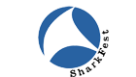ANGEL SHARK SPONSORSHIP
$10,000 (10 available)

Angel Shark Sponsors have the opportunity to engage and educate SharkFest attendees on their technology and its ability to enhance the Wireshark user experience, starting with the Welcome Dinner on Monday June 25th.

Please note that we attempt to limit the number of competing technologies represented by sponsors, so those submitting requests for sponsorships early are given preference.

Includes:
- Participation in the Vendor Technology Showcase Treasure Hunt & Raffle on Tuesday evening, June 26th.
- Two complimentary registrations for staff or customers to attend SharkFest sessions ($2,590 value).
- 6’ draped table for product demonstrations, literature hand-outs, giveaways, leads collection and general SharkFest attendee engagement.
- Signage for the Vendor Technology Showcase.
- Your company’s logo and link on the official SharkFest conference website and in all marketing materials associated with the event.
- Company’s description (up to 100 words) on the official SharkFest conference Sponsor web page.
- Inclusion in social media campaigns.

WELCOME DINNER SPONSORSHIP
$6,500 (1 available)

Includes:
- Your company’s logo and link on the official SharkFest conference website Sponsorship page and in all marketing materials associated with the Welcome Dinner event.
- Welcome Dinner announcement of your company’s sponsorship of the event.
- “SharkFest’17 US Welcome Dinner” signage in multiple locations in the Computer History Museum with your company’s logo.
- After dinner mints for all attendees in tins with SharkFest and your company’s logos.

WIRESHARK GROUP PACKET PALOOZA COMPETITION SPONSORSHIP
$5,000 (1 available)

Group Packet Competitions test attendee packet analysis ability and are eagerly-anticipated conference activities. SharkFest’18 US will introduce a new Group Packet Competition during the Wednesday, June 27th dinner event, with awards for winners presented at evening’s end by the funding sponsor.

Includes:
- Your company’s logo and link on the official SharkFest conference website Sponsorship page and in all marketing materials associated with the Packet Palooza Challenge.
- Signage for the Packet Palooza evening thanking your company for funding the Challenge.
- Announcement before and after the event recognizing your company for the sponsorship.
- Award presentation to each Challenge winner by sponsor representative at evening’s end.

LIVE MUSIC SPONSORSHIP (for Technology Showcase Event)
$2,000 (1 available)

Live music is a hallmark of SharkFest conferences. SharkFest’18 US will feature another group of talented local musicians playing 3 sets while attendees dine and interact with sponsors during the Sponsor Technology Showcase on Tuesday, June 26th.

Includes:
- Your company’s logo and link on the official SharkFest conference website Sponsorship page and in all marketing materials associated with the Sponsor Technology Showcase.
- Signage thanking your company for bringing musical joy and harmony to the event!
- Announcement before and after the performance thanking you for your live music sponsorship.

WELCOME GIFT SPONSORSHIP
$2,500 (3 available)

Each year, attendees are greeted with a Welcome Bag that includes gift items branded for the specific Sharkfest conference. This sponsorship provides the opportunity to underwrite the cost of items chosen by SharkFest conference management and receive recognition for your contribution to the success and retained memory of the SharkFest’18 US event.

Includes:
- Your company’s logo and link on the official SharkFest conference website Sponsorship page and in all marketing materials associated with the event.
- 1 piece of literature in each Welcome Bag
- Signage at the Reception area thanking your company for sponsoring SharkFest’18 US Welcome gifts.

SharkFest ’18 US
Wireshark Developer and User Conference

SPONSORSHIP APPLICATION FORM

Company: ________________________________________________________________________

Address: ________________________________________________________________________

City: ____________________________ State: _______ Zip: ________________________

Primary Event Contact: ____________________________________________________________

Primary Event Contact Title:________________________________________________________

Phone: ______________________________________

Email: ______________________________________

Sponsorship Choice (Please Select one or more Options)

____ Angel Shark Sponsor $10,000

____ Welcome Dinner Sponsor $6,500

____ Wireshark Group Packet Competition Sponsor $5,000

____ Live Music Sponsor $2,000

____ Welcome Gift Sponsor $2,500

*PLEASE NOTE! Sponsorships are allotted on a first-come, first-served basis. We will inform you if a sponsorship category is already subscribed when you submit your sponsor request form.

TOTAL AMOUNT DUE: $ __________________

Payment Terms
Full payment (by check or EFT) must be received within 30 days of sponsorship agreement signing.

Technology Showcase Exhibit Space Location
Exhibit space location will be confirmed 30 days before the conference start date.

Cancellation Policy
Written cancellations received before April 1, 2018 will be entitled to a 50% refund. No refunds will be given for cancellations after April 1, 2018.

Payment Details
If paying by check, please make payable to Riverbed Technology, Inc. and send to the address listed below within 30 days of submission of this form.

Riverbed Technology
Attn: Janice Spampinato – SharkFest’18 US
680 Folsom Street, 6th Floor
San Francisco, CA 94107
janices@riverbed.com
(415) 527.4300

If paying by EFT, please follow these instructions:
Wells Fargo Operating Account (#1002)
Routing Number/ ABA: 121000248 (Riverbed Technology Operating)
Account Number: 4121680300
Swift Code: WFBIUS6S
Bank Address: 400 Hamilton Avenue, 2nd Floor, Suite 210
Palo Alto, CA 94301-1833

PLEASE Reference SharkFest’18 US Sponsor Payment on Funds Transfer Form

SharkFest ’18 US
Wireshark Developer and User Conference

SHARKFEST’18 US SPONSORSHIP AGREEMENT

Liability: Sponsor assumes full responsibility and liability for its acts and omissions and the acts and omissions of its agents, employees and independent contractors, whether acting within or outside of the scope of their authority and Sponsor shall indemnify, defend, and hold harmless Riverbed and the SHARKFEST event facilities from all claims, losses, liabilities, damages, expenses and costs resulting directly or indirectly from such acts or omissions. Sponsor shall maintain insurance policies with sufficient coverage to protect the financial interests of both Sponsor and Riverbed in the event of a claim arising out of this Agreement. Contractor will deliver to Riverbed insurance certificates showing such coverage upon request.

Use and Operation of Exhibitor Booth or Pod Properties: Subleasing of exhibit space is not allowed. Your exhibit must be staffed during exhibit hours. All demonstrations or other promotional activities must be confined to the limits of their space, except as defined in the sponsorship.

Security and Liability: Neither Riverbed, nor its agents or representatives, will be held responsible for any injury, loss or damage that may occur to the Sponsor, Sponsor employees or the Sponsor’s property. Sponsors should insure their property from the time it arrives at the event until it leaves.

Care of Building and Equipment: Sponsor must not damage or deface the walls, floors, or equipment of any SHARKFEST event facility. If such damage occurs, the Sponsor shall be liable to the owner of the property damaged. All materials used in decoration must be flame-proofed. Electric wiring must conform to the National Electric Code Safety rules and all other applicable rules, regulations, fire laws, electrical codes and other applicable laws. Any hazardous, combustible, or explosive materials are not permitted in the any SHARKFEST event facility.

Choice of Law; Jurisdiction: This Agreement shall be governed and enforced in accordance with the laws of the state of California and its federal and state courts. In the event that it shall be necessary for Riverbed to bring suit to enforce any of its rights hereunder, Riverbed shall be entitled to recover all costs of such suits including reasonable attorney’s fees.

Regulations: Exhibit areas at SHARKFEST event facilities are subject to change to comply with laws or the event facility regulations. Riverbed further reserves the right to reallocate space in the interest of a better showing of exhibits or for any reason. Sponsor must comply with all SHARKFEST policies, the policies of SHARKFEST event facilities, and with all laws, regulations, and ordinances.

This Sponsorship Agreement (this “Agreement”) is made between Riverbed Technology, Inc. (“Riverbed”) and the Sponsor signing below.

Sponsor Company: _________________________________________________________________

Authorized Signature: _________________________________________________________________

Printed Name: _________________________________________________________________

Title: _________________________________________________________________

Date: _____________________________________________

Please email your signed Agreement to: sharkfest@riverbed.com

